**A client server-based program using UDP to find if the number entered is even or odd.**

**udpClientEO.java**

/*Program which finds entered number is even or odd*/

import java.io.*;

import java.net.*;

public class udpClientEO {

public static void main(String args[]) {

try {

DatagramSocket ds = new DatagramSocket(1000);

BufferedReader br = new BufferedReader(new InputStreamReader(System.in));

System.out.println("Enter a number : ");

String num = br.readLine();

byte b[] = new byte[1024];

b = num.getBytes();

DatagramPacket dp = new DatagramPacket(b, b.length, InetAddress.getLocalHost(), 2000);

ds.send(dp);

byte b1[] = new byte[1024];

DatagramPacket dp1 = new DatagramPacket(b1, b1.length);

ds.receive(dp1);

String str = new String(dp1.getData(), 0, dp1.getLength());

System.out.println(str);

} catch (Exception e) {

e.printStackTrace();

}

}

}

**udpServerEO.java**

/*Program which finds entered number is even or odd */

import java.io.*;

import java.net.*;

public class udpServerEO {

public static void main(String args[]) {

try {

DatagramSocket ds = new DatagramSocket(2000);

byte b[] = new byte[1024];

DatagramPacket dp = new DatagramPacket(b, b.length);

ds.receive(dp);

String str = new String(dp.getData(), 0, dp.getLength());

System.out.println(str);

int a = Integer.parseInt(str);

String s = new String();

if (a % 2 == 0) {

s = "Number is even";

} else {

s = "Number is odd";

}

byte b1[] = new byte[1024];

b1 = s.getBytes();

DatagramPacket dp1 = new DatagramPacket(b1, b1.length, InetAddress.getLocalHost(), 1000);

ds.send(dp1);

} catch (Exception e) {

e.printStackTrace();

}

}

}

**Output:**

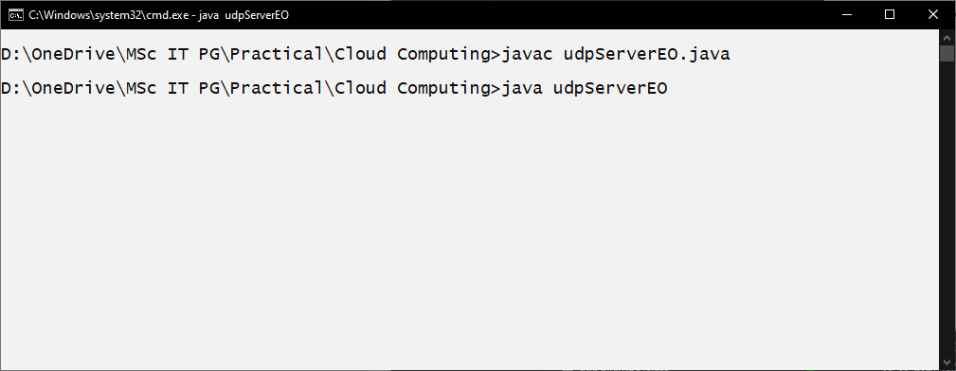

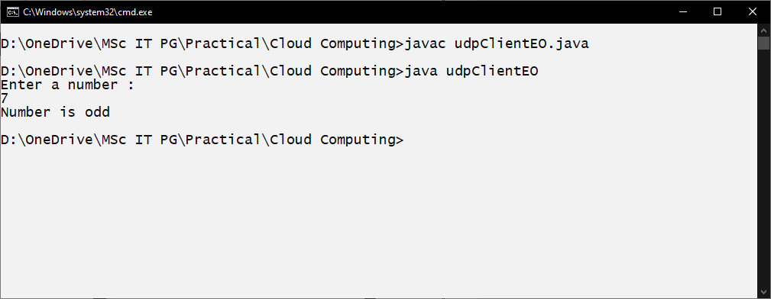

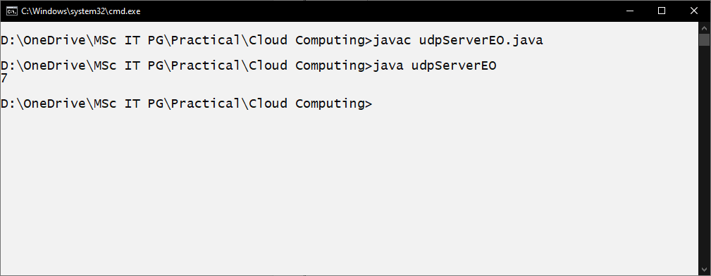

**A program to implement simple calculator operations like addition, subtraction, multiplication and division**

**RPCClient.java**

import java.io.*;

import java.net.*;

class RPCClient {

RPCClient() {

try {

InetAddress ia = InetAddress.getLocalHost();

DatagramSocket ds = new DatagramSocket();

DatagramSocket ds1 = new DatagramSocket(1300);

System.out.println("\nRPC Client\n");

System.out.println("Enter method name and parameter like add");

while (true) {

BufferedReader br = new BufferedReader(new InputStreamReader(System.in));

String str = br.readLine();

byte b[] = str.getBytes();

DatagramPacket dp = new DatagramPacket(b, b.length, ia, 1200);

ds.send(dp);

dp = new DatagramPacket(b, b.length);

ds1.receive(dp);

String s = new String(dp.getData(), 0, dp.getLength());

System.out.println("\nResult = " + s + "\n");

}

} catch (Exception e) {

e.printStackTrace();

}

}

public static void main(String[] args) {

new RPCClient();

}

}

**RPCServer.java**

import java.util.*;

import java.net.*;

class RPCServer {

DatagramSocket ds;

DatagramPacket dp;

String str, methodName, result;

int val1, val2;

RPCServer() {

try {

ds = new DatagramSocket(1200);

byte b[] = new byte[4096];

while (true) {

dp = new DatagramPacket(b, b.length);

ds.receive(dp);

str = new String(dp.getData(), 0, dp.getLength());

if (str.equalsIgnoreCase("q")) {

System.exit(1);

} else {

StringTokenizer st = new StringTokenizer(str, " ");

int i = 0;

while (st.hasMoreTokens()) {

String token = st.nextToken();

methodName = token;

val1 = Integer.parseInt(st.nextToken());

val2 = Integer.parseInt(st.nextToken());

}

}

System.out.println(str);

InetAddress ia = InetAddress.getLocalHost();

if (methodName.equalsIgnoreCase("add")) {

result = "" + add(val1, val2);

} else if (methodName.equalsIgnoreCase("sub")) {

result = "" + sub(val1, val2);

} else if (methodName.equalsIgnoreCase("mul")) {

result = "" + mul(val1, val2);

} else if (methodName.equalsIgnoreCase("div")) {

result = "" + div(val1, val2);

}

byte b1[] = result.getBytes();

DatagramSocket ds1 = new DatagramSocket();

DatagramPacket dp1 = new DatagramPacket(b1, b1.length, InetAddress.getLocalHost(), 1300);

System.out.println("result : " + result + "\n");

ds1.send(dp1);

}

} catch (Exception e) {

e.printStackTrace();

}

}

public int add(int val1, int val2) {

return val1 + val2;

}

public int sub(int val3, int val4) {

return val3 - val4;

}

public int mul(int val3, int val4) {

return val3 * val4;

}

public int div(int val3, int val4) {

return val3 / val4;

}

public static void main(String[] args) {

new RPCServer();

}

}

**Output:**

